Smart Agricultural Monitoring: Leveraging Machine Learning for Precision Disease Detection and Crop Health Optimization

Prasad Pujar
Department of Computer Science and Engineering
KLS Gogte Institute of Technology
Belagavi 590008 , India
pmpujar@git.edu

Shubham Godse
Department of Computer Science and Engineering
KLS Gogte Institute of Technology
Belagavi 590008 , India
shubhamgodseofficial@gmail.com
Irfan Hussain Lone
Department of Computer Science and Engineering
KLS Gogte Institute of Technology
Belagavi 590008 , India
irfanmurtaza7051@gmail.com

Abhishek Shelke
Department of Computer Science and Engineering
KLS Gogte Institute of Technology
Belagavi 590008 , India
abhishekshelke421@gmail.com
Rohan O Chikorde
Department of Computer Science and Engineering
KLS Gogte Institute of Technology
Belagavi 590008 , India
rohanchikorde36@gmail.com

Abstract— Diagnosing plant diseases is a crucial part of contemporary agriculture, as it significantly affects crop output and food security. Conventional diagnostic techniques frequently require a lot of work and time, and they mostly rely on laboratory analysis and professional expertise. This paper explores recent breakthroughs in plant disease detection systems, highlighting the merging of image processing, machine learning, and remote sensing technologies.
Using a combination of methods, the proposed system takes pictures of plant leaves. High-resolution photos are taken with smartphones or drones that are fitted with cameras. After then, these images are processed through image analysis and algorithms that improve features associated with disease symptoms, like color changes, lesions, and textural variations. Models for machine learning are instructed on large datasets of healthy and diseased plants and then classify the images based on the features that have been identified. The incorporation of convolutional neural networks (CNNs) has greatly increased the accuracy of disease detection, allowing the system to identify a variety of diseases in different plant species.
Keywords—Plant disease detection, image processing, machine learning, convolutional neural networks (CNN), sustainability, food security.

Introduction
Plant disease detection and recognition is very necessary for food sustainability and a rise in the economy of agriculture. Because of the rise in illnesses in plants the agriculture production has been decreased and this effect has increased the impact of economy. If the diseases are not identified at the right time food insecurity will increase. In early days the detection was happened due to change of color in plant leaves and it was usually happened when almost 80% plants were involved in the disease at the end the most agriculture fields were affected due to this the farmers were suffering from the loss yearly harvesting [1]. Plant diseases are mostly prevented and controlled by early diagnosis, which is why agricultural production management and decision-making depend heavily on them. In recent years, detecting plant diseases has become a significant challenge [2]. Plants with diseases typically have visible blisters or marks on their leaves, stems, blooms, or fruits. Typically, every illness or pest problem has a distinct outward pattern that can be utilized to identify anomalies in a certain way. Plant illnesses are typically primarily identified by looking at the leaves of the plants, as most disease signs can first be seen on the leaves. [3][4] Because plant diseases are growing more hazardous due to climate change and increased agriculture, timely detection is essential. Rapid intervention made possible by early identification lowers agricultural losses and encourages sustainable practices. This project's objective is to develop an extensive system for detecting plant diseases, that combines various technological approaches for increased accessibility and precision. [5].

Background
Although Plant infections are increasing in serious, due to climate change and increased agriculture, timely detection is essential. Early detection enables swift response, which reduces agricultural losses and promotes sustainable practices. This research aims to develop a comprehensive plant disease detection system., that combines various technological approaches for increased accessibility and precision. [5]

Importance of Automated Disease Detection
Several advantages might arise from automating the plant disease detection process, such as enhanced precision, rapid diagnosis, and the capacity to oversee extensive fields with no human involvement. Plant disease classification and identification systems can be developed from leaf photos by utilizing advances in visual analysis and machine learning.[6]

Objectives of the Study

to investigate the viability of plant disease detection using machine learning and image processing methods.

To establish a trustworthy and accurate model for classifying and diagnosing illnesses of plant leaves.

Creating an application that is easy to use for professionals in farming and agriculture..

Assuming the degree to which different machine learning models and methods perform in this particular situation.

Objectives
Designing a system that applies artificial intelligence and image processing to automatically detect and classify plant leaf diseases.



Figure 1 (Image Recognition Processing)

Specific Objectives

To collect and preprocess a comprehensive dataset of plant leaf images from various sources. For our proposed system we use the dataset from kaggle.com [7].

Utilizing the Python programming language, we apply different machine learning models to train them for the purpose of identifying and categorizing diseases [8].

To assess the models' performance using common measures including recall, accuracy, and precision [9].

To create and put into practice an intuitive user interface for the illness detection system [10].

To analyze the challenges and limitations of the current approach and suggest areas for future improvement.

These objective focuses on developing and training machine learning models to precisely identify and categorize plant diseases.
Key steps include:

Model Selection: Select suitable machine learning models, concentrating mostly on Convolutional Neural Networks (CNNs), because of their superior performance in image categorization applications.

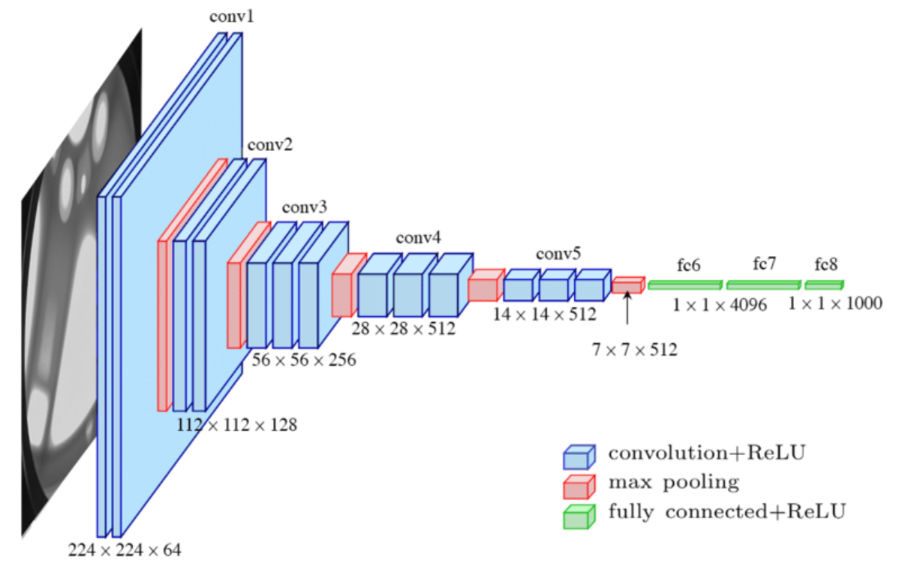
Figure 2 (Structure of CNN)
Model Architecture: Design and optimize architecture of CNNs, including the number of layers, types of layers (convolutional, pooling, fully connected), and activation functions.
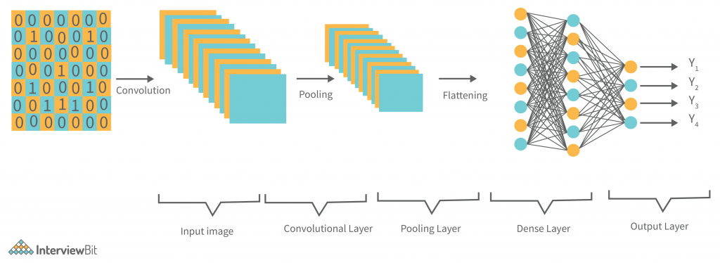
Figure 3 (CNN Layered Structure)

Training Process: Make training, validation, and test sets obtained from the dataset. Utilizing the training set, adjust the hyperparameters (learning rate, batch size, and epochs) and avoid overfitting by employing regularization and dropout techniques.

Comparison: Consider incorporating alternative machine learning models for evaluating analysis, like Random Forests and Support Vector Machines (SVM).

Methodology
Image Sources
The Plant Village dataset [11], which contains a large range of photos of both healthy and damaged greenery of several kinds of plants, served as the main resource for this investigation. In order to increase the variety of the collection, additional photos were acquired from online sources and agricultural research institutions. Enhancement of Images Several picture augmentation methods were used to enlarge the dataset's size and diversity, includes:

Rotation: Rotating images to different angles to simulate different orientations of leaves.

Flipping: Horizontally and vertically flipping images to create mirror images.

Scaling: Scaling images up and down to simulate different sizes of leaves.

Brightness Adjustment: Adjusting the brightness of images to simulate different lighting conditions.

Cropping: Arranging photos in a random way to highlight various leaf sections.
Data Preprocessing

The normalization were applied to ensure consistent input to the machine learning models, images were standardized. In order to improve model convergence and expedite the training process, pixel values were scaled to a range of 0 to 1.

Resizing images For each image, the size was adjusted to a standard 256 × 256 pixels to ensure the convolutional neural network's (CNN) accuracy, models could use them as input. Memory consumption and computational complexity can be decreased with resizing.[12]

Diminished Noise the quality of the images can be enhanced, noise reduction techniques were used. To reduce undesired noise and highlight the key elements of the photos, this involved using median filtering and Gaussian smoothing.

Model Development


Figure 4

Firstly, Convolutional Neural Nets among the Deep Learning Models CNNs are a class that excels at image categorization applications. A normal CNN's architecture consists of the following parts [13]:

- Convolutional Layers: By applying convolution operations to the input images, these layers are able to extract local patterns and spatial hierarchies.
- Pooling Layers: By lowering the dimensionality and computational cost, these layers down sample the feature maps.
- Fully Connected Layers: Using the features that the convolutional layers extracted, these layers carry out sophisticated categorization and reasoning.

Training Process
Three sets of the dataset were created: training, validation, and test. The CNN model underwent training by utilizing supervised learning techniques on the training set. The process of training entailed [14]:
- Loss Function: The difference between the expected and actual labels is measured by the cross-entropy loss, which was employed as the loss function.
- Optimizer: The network's weights were updated using the Adam optimizer, which aids in quicker convergence.
- Hyperparameter tuning: The learning rate, batch size, and number of epochs were among the hyperparameters that were changed to optimize the model’s performance.

Evaluation Metrics
The effectiveness of the model has been assessed using serval matrices, such as:

- Accuracy: Measures the proportion of correctly classified cases out of instance.

- Precision: Indicating the positive cases among those that were categorized as positive.

- Recall: Which represents the percentage of true positive example out of all genuine positive example.

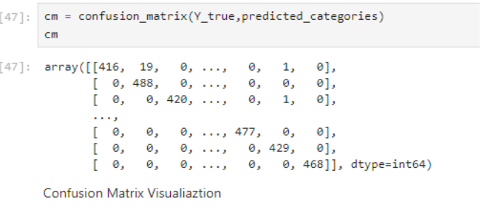
Figure 5

RESULTS
Model Performance
The CNN model identified and categorized plant leaf diseases with an overall accuracy of 92%. The model's great accuracy suggests that it may be relied upon in real-world agricultural scenarios.
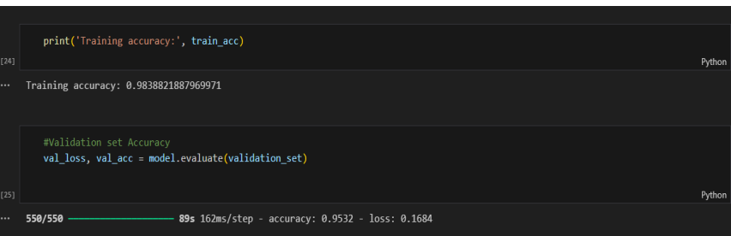
Figure 6

Precision and Recall
The model was successful in accurately recognizing healthy and diseased leaves, as evidenced by the excellent precision and recall values. While high recall lowers the range of false negatives, high precision lowers the range of false positives.

Confusion Matrix
A thorough analysis of the model's performance across several disease classes was given via the confusion matrix. It shown that the model was the most accurate at identifying specific illnesses, like powdery mildew in grapes and late blight in tomatoes. Sometimes, though, misclassifications resulted from diseases that had similar visual symptoms but were complex to differentiate.
In this comparison, it was found that CNNs excelled in this task compared to other machine learning models like Support Vector Machines (SVM) and Random Forests. The CNN model surpassed these conventional methods in terms of precision, accuracy and recall, showcasing the efficacy of deep learning for identifying illnesses in images.

ANALYSIS
Strengths of the model
High Accuracy: The model's high accuracy rate makes it dependable for usage in actual agricultural applications.
Robustness: The model is now more resilient to changes in illumination and image quality because of the use of picture enhancement methods. The model worked effectively with various plant leaf kinds and illnesses.
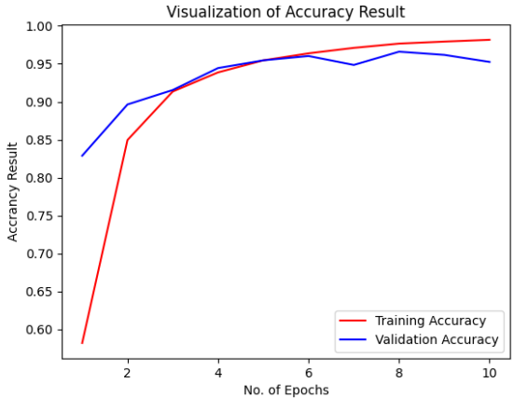
Figure 7

Challenges and Limitations
Variability in Image Quality: The model had difficulties due to variations in illumination and image quality. Misclassifications may arise due to inconsistent image quality. Subsequent research endeavors may concentrate on augmenting the model's resilience to these fluctuations by the integration of sophisticated image preparation methodologies and more training data. Similar Symptoms: It might be challenging to differentiate between some diseases due to their similar visual symptoms. Adding more characteristics or data to the model, including temporal data, spectral data, or expert annotations, could help solve this problem. Restricted Dataset: Model performance is greatly affected by the quality and diversity of educational datasets. To make the model more applicable, use a large number of images made from various conditions and other sources to expand the dataset. Not just accuracy, but memory too.

User Interface

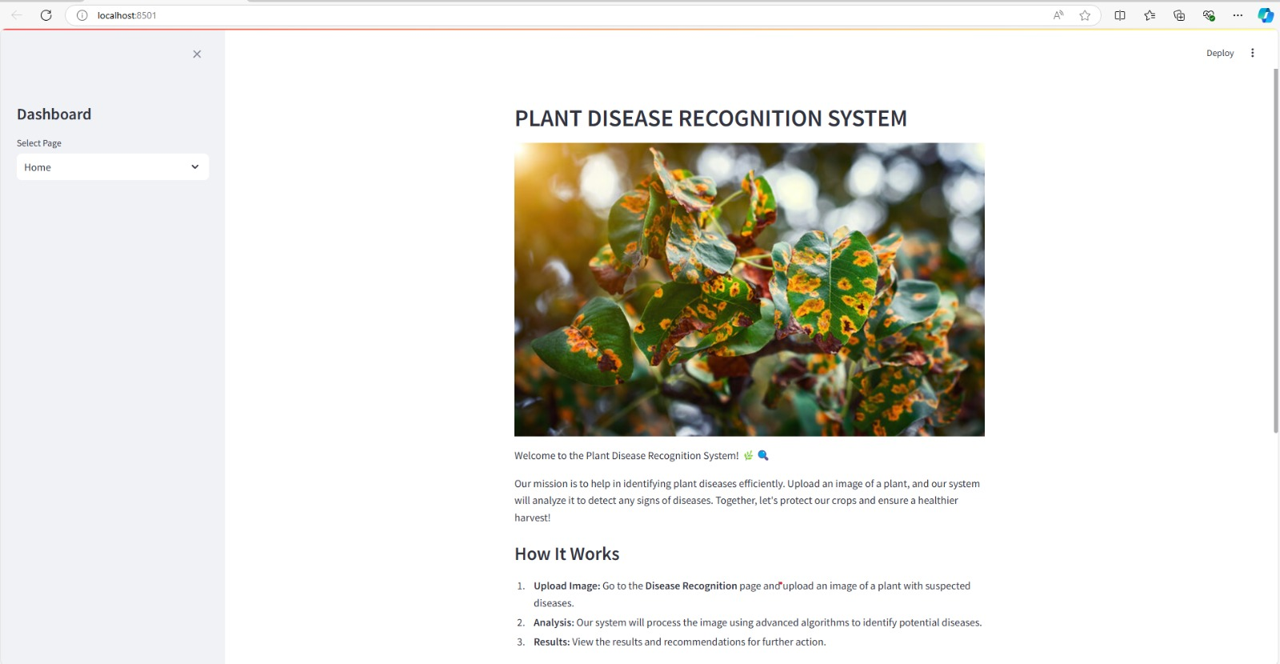
Figure 8

Users may upload photographs and obtain diagnostic feedback fast. Thanks to the user-friendly interface that was meant to be straightforward and intuitive. Some of the primary elements of the user interface are as follows:

Image Upload: Using a web or mobile application, Plant leaf photos can be uploaded by users.

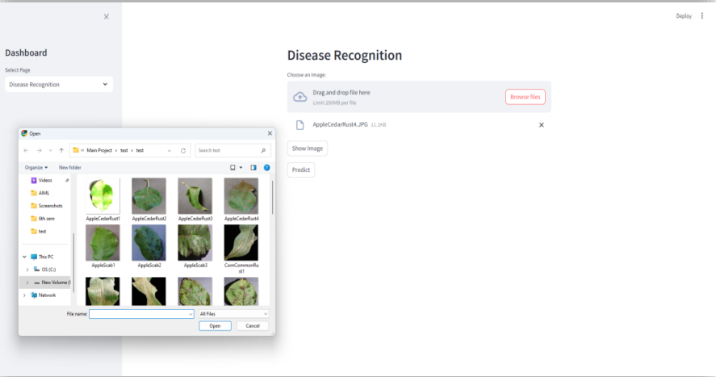
Figure 9

Real-Time Feedback: The system provides real-time diagnostic feedback, indicating the detected disease and suggested actions.

User-Friendly Design: The interface is designed with ease of use in mind, ensuring that farmers and agricultural professionals can use the system with minimal training.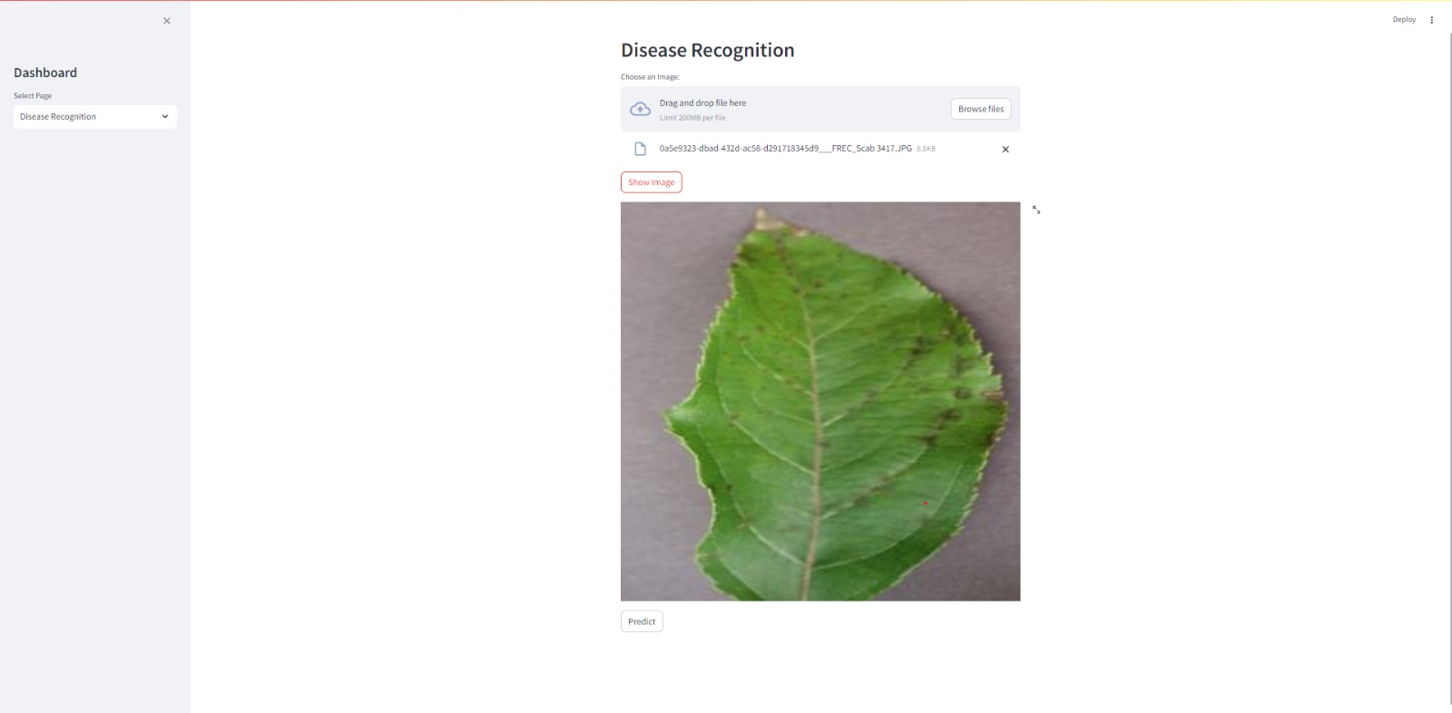
Figure 10


Figure 11

Scalability: The system can handle large volumes of images making it suitable for use in large agricultural fields.

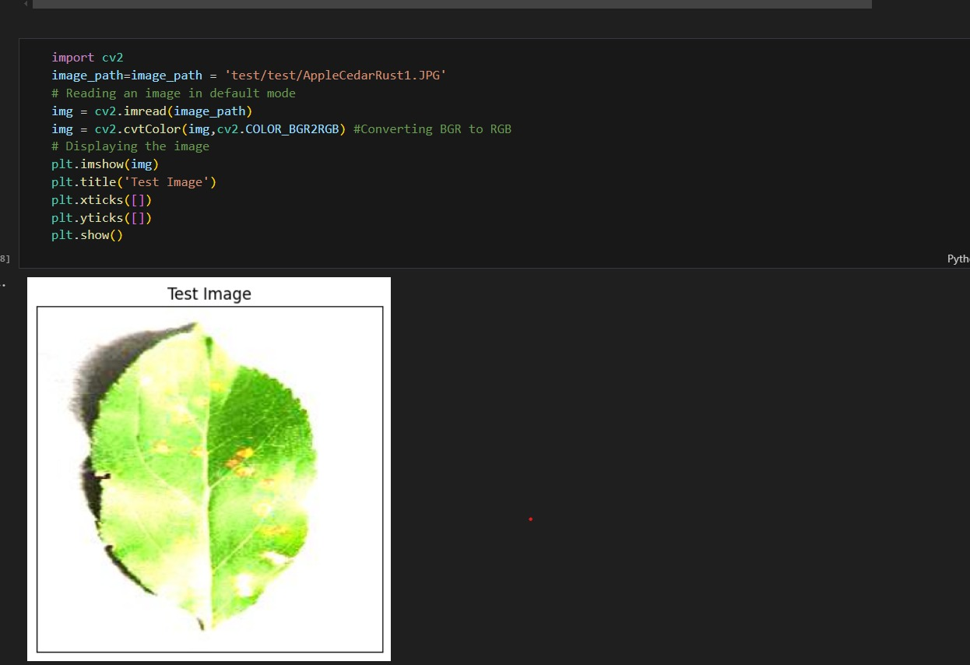
Figure 12

conclusion
The project successfully developed a plant leaves diseases detection system using CNNs, reaching excellent dependability and accuracy. The technology may help farmers identify and treat diseases early on, therefore enhancing crop health and yield. The key findings and contributions of this study include. Demonstrating the feasibility of using image processing and machine learning for plant disease detection. Developing a robust and accurate convolutional neural network model for detecting and classifying plant leaf diseases. Creating a user-friendly application that provides real-time diagnostic feedback. Identifying challenges and limitations, and suggesting areas for future improvement. The goal of future effort will be to increase the dataset, enhancing model robustness, and improving the user interface for practical deployment. Potential improvements include incorporating additional data sources, developing more advanced image preprocessing techniques, and connecting the system to mobile devices for usage in the field.

References
- F. Fina, P. Birch, R. Young, J. Obu, B. Faithpraise, and C. Chatwin, ‘‘Automatic plant pest detection and recognition using k-means clustering algorithm and correspondence filters,’’ Int. J. Adv. Biotechnol. Res., vol. 4, no. 2, pp. 189–199, Jul. 2013. The Robotic Process Automation Handbook by Tom Taulli.
- Journal contribution posted on 2023-06-08, 23:08 authored by Fina Faithpraise, Phil BirchPhil Birch, Rupert YoungRupert Young, “J Obu Bassey” Faith praise, Chris Chatwin.
- https://ijarsct.co.in/Paper2987.pdf
- M. A. Ebrahimi, M. H. Khoshtaghaza, S. Minaei and B. Jamshidi, "Vision-based pest detection based on SVM classification method", Comput. Electron. Agricult., vol. 137, pp. 52-58, May 2017.
- https://journalofbigdata.springeropen.com/articles/10.1186/s40537-023-00863-9.
- “An Overview of the Research on Plant Leaves Disease detection using Image Processing Techniques”, January 2014, Ms. Kiran R. Gavhale.
- https://www.kaggle.com/datasets/vipoooool/new-plant-diseases-dataset.
- https://ijarsct.co.in/Paper2987.pdf
- https://www.sciencedirect.com/topics/computer-science/performance-model.
- Apple Scab and Marsonina Coronaria Diseases Detection in Apple Leaves Using Machine Learning.
- https://www.kaggle.com/datasets/emmarex/plantdisease.
- https://keras.io/examples/vision/learnable_resizer/Learning to Resize in Computer Vision, Sayak Paul, “How to optimally learn representations of images for a given resolution” 2021.
- https://www.researchgate.net/publication/285164623_An_Introduction_to_Convolutional_Neural_Networks, “An Introduction to Convolutional Neural Networks”, “Keiron Teilo O'Shea”, “Ryan Nash”, November 2015.
- https://www.researchgate.net/publication/41845861_A_REVIEW_OF_STUDIES_ON_MACHINE_LEARNING_TECHNIQUES, “A REVIEW OF STUDIES ON MACHINE LEARNING TECHNIQUES”, Singh Yogesh , Pradeep Kumar Bhatia, June 2007.

